Information Technology
What is Information Technology ?
Information Technology (IT) refers to the use of computers, software, networks, and other digital systems to store, process, transmit, and manage information.
What is protocol?
A protocol is a set of rules that govern how two or more entities communicate and interact. In technology, it dictates how data is transmitted, received, and interpreted between devices, ensuring effective and accurate communication over a network. In a broader sense, it refers to established customs and procedures for formal situations, such as diplomatic or medical protocols.
Examples of protocols
Networking protocols: These are essential for all internet and network communication.
- TCP/IP:A fundamental suite of protocols that breaks data into packets, addresses them, and routes them to their destination.
- HTTP: The protocol used to transfer web pages across the internet.
- SMTP/POP: Protocols used for sending and receiving emails.
- HTTPS: which stands for HyperText Transfer Protocol Secure, is the secure version of the standard HTTP protocol used to send data between a web browser and a website. It encrypts the information exchanged, making it safe from eavesdropping and attacks, which is crucial for sensitive data like login credentials and financial information.
- FTP: File Transfer Protocol, is a standard network protocol used to transfer computer files between a client and a server on a computer network. It works by establishing two TCP connections to handle control commands and to transfer data, enabling users to upload, download, and manage files across different operating systems.
IT vs. Computer Science:
IT: The use and management of computer systems, networks, and software to store, process, and share information.
Computer Science: The study of computation, algorithms, and the design of computer systems and software.
Importance of IT:
- Automation of tasks and operations
- Efficient communication (email, messaging, video calls)
- Data storage and analysis for decision-making
- Global connectivity through the internet
- Innovation in fields like healthcare, finance, education, and entertainment
Core Components of IT
- Hardware – Physical devices (computers, servers, routers, etc.)
- Software – Programs and operating systems that run on hardware
- Networking – Connecting systems for data sharing (Internet, LAN, WAN)
- Data – The raw facts that are processed into meaningful information
- People and Processes – Users, IT professionals, and workflows managing systems
Computer Hardware
- Input devices: Keyboard, Mouse, Scanner
- Output devices: Monitor, Printer, Speakers
- CPU: The brain of the computer (Control Unit + ALU)
- Memory: RAM (volatile) and ROM (non-volatile)
- Storage: Hard disks, SSDs, Optical drives
Computer Software
- System Software – Operating systems (Windows, Linux, macOS)
- Application Software – Tools for end users (MS Office, browsers, databases)
- Utility Software – File management, antivirus, backup tools
Networking and Internet
- Computer networks connect devices to share data and resources.
- Types: LAN (Local), MAN (Metropolitan), WAN (Wide Area), PAN (Personal)
- Internet: A global network enabling email, web browsing, and communication.
- Network Devices: Router, Switch, Hub, Modem, Access Point.
*Network devices note*
- Router: A router is a networking device that connects multiple computer networks, such as a home network to the internet. It directs data traffic by forwarding data packets to their intended destinations and allows devices on a network to share a single internet connection. In essence, it acts as a traffic director for your network.
- Switch: A network switch is a hardware device that connects multiple devices, such as computers and printers, within a local area network (LAN). It uses packet switching to intelligently forward data packets directly to the correct destination device based on its MAC address, which makes data transfer more efficient than a hub.
- Hub: A hub is a networking device that connects multiple computers or devices to a single network and acts as a central connection point. When it receives a data frame, it forwards the data to all other connected ports, regardless of the intended recipient. This broadcasting method means a hub is a simple, low-cost device that lacks the intelligence of a switch, which only sends data to the specific port it's meant for, leading to potential collisions and slower performance.
- Modem: A modem is a device that converts digital signals from your computer or other devices into analog signals for transmission over telephone or cable lines, and vice versa, to connect to the internet. It acts as a translator, allowing digital devices to communicate over analog networks by modulating and demodulating signals. Modems work with your Internet Service Provider (ISP) to provide your home with internet access and often work with routers to share the connection with multiple devices, notes Netgear.
- Access point: An access point is a networking device that creates a wireless local area network (WLAN) by allowing devices like laptops and phones to connect to a wired network using radio waves. It acts as a bridge, converting the wired signal from a router into a wireless one to extend a network's coverage and support multiple devices simultaneously.
Topology: In computer networking, topology is the arrangement of a network's components, such as nodes (like computers) and links (like cables), describing both the physical layout and the logical flow of data. It determines how devices are connected and how information travels between them, which impacts network performance, reliability, and scalability. There are two main types: physical topology (the physical layout of wires and devices) and logical topology (the path data takes through the network).
Common Types of Network Topologies
- Bus Topology: All devices connect to a single, central cable (the bus). If the bus cable fails, the entire network goes down.
- Star Topology: All devices connect to a central hub or switch. If one cable fails, only that one device is affected.
- Ring Topology: Each device is connected in a circular fashion to two other devices.
- Mesh Topology: Each device is connected to multiple other devices. In a full mesh, every device is connected to every other device, providing a highly reliable network with redundant paths.
- Tree Topology: A hybrid of bus and star, this topology has a central root node from which other nodes are connected in a hierarchical structure.
- Hybrid Topology: A combination of two or more different topologies.

Database Management Systems (DBMS)
What is data?
Data is raw facts, figures, or information that can be processed to create meaning. It can be anything from numbers, words, and measurements to images and observations. In computing, data is stored electronically, often in structured or unstructured formats, and is the raw material that is transformed into information through analysis.
- Database: Structured data organized for quick access and management.
- DBMS Examples: MySQL, Oracle, SQL Server
- SQL: Structured Query Language for managing databases.
- Importance: Data integrity, security, and scalability.
Information Security and Cybersecurity
- Protects data and systems from unauthorized access or damage.
- Threats: Viruses, Malware, Phishing, Ransomware
- Security Measures: Firewalls, Encryption, Authentication
- Policies: Data backup, user training, network monitoring.
Cloud Computing
- Provides computing services (servers, storage, databases) over the Internet.
- Models: IaaS, PaaS, SaaS
- Benefits: Scalability, cost-efficiency, accessibility
- Providers: AWS, Microsoft Azure, Google Cloud
Emerging IT Technologies
- Artificial Intelligence – Machine learning, automation, NLP
- Internet of Things (IoT) – Smart devices connected via the Internet
- Blockchain – Secure, decentralized data ledger
- Big Data – Analysis of massive datasets for insights
Applications of IT in Business
- E-commerce and Digital Marketing
- Enterprise Resource Planning (ERP)
- Customer Relationship Management (CRM)
- Business Intelligence and Analytics
- Remote work, collaboration, and automation tools

IT in Education and Society
- E-learning platforms and virtual classrooms
- Digital libraries and research tools
- Social media and digital communication
- IT’s impact on social awareness and global connectivity

The Role of Information Technology in Modern Business
Information Technology (IT) plays a vital role in transforming how businesses operate, communicate, and compete in today’s digital world. It supports every aspect of modern business — from daily operations to strategic decision-making.
Key roles of IT in modern business:
- Increased efficiency: IT automates repetitive tasks, reduces manual labor, and minimizes errors, which leads to increased productivity and consistency across departments.
- Improved communication: It provides tools like email, instant messaging, and video conferencing that facilitate real-time communication and collaboration among employees, clients, and partners.
- Data-driven decision-making: Advanced analytics tools allow businesses to collect, analyze, and interpret vast amounts of data to gain insights for strategic planning and performance monitoring.
- Innovation and competitiveness: IT provides platforms and tools for research and development, allowing companies to create innovative products and services and gain a competitive edge.
- Supply chain optimization: Sophisticated software helps businesses track inventory, manage logistics, and improve demand forecasting, which reduces costs and ensures timely deliveries.
- Enhanced customer experience: IT systems like CRM software allow businesses to track customer information and preferences, while tools like chatbots provide instant customer service.
- Cybersecurity: IT professionals use advanced security measures like firewalls, encryption, and intrusion detection systems to protect sensitive data from cyber threats and safeguard the company's reputation.
- Scalability and flexibility: Cloud computing, for example, provides businesses with scalable storage and access to data from anywhere, allowing them to grow and adapt their operations as needed.
Enterprise Resource Planning
Enterprise Resource Planning (ERP) is a software system that integrates and manages core business processes like finance, HR, supply chain, and manufacturing into a single, unified platform. By centralizing data, ERP streamlines operations, improves efficiency, and provides a real-time, single source of truth for an organization's activities. It allows different departments — such as finance, HR, sales, supply chain, inventory, and manufacturing — to share information and work efficiently together.
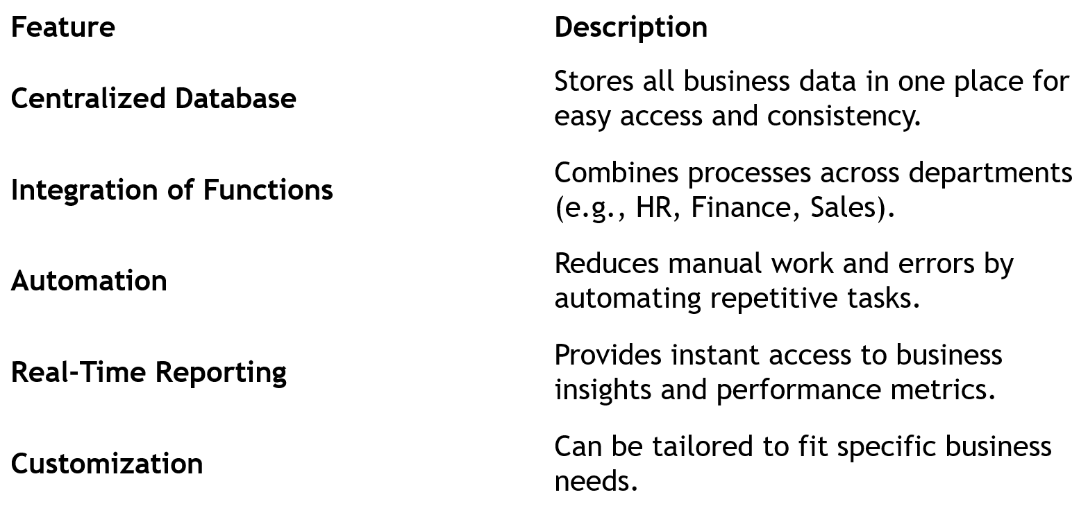
Key Features of ERP Systems
Core Modules in ERP
- Finance and Accounting
- Human Resource Management (HRM)
- Inventory Management
- Sales and Marketing
- Customer Relationship Management (CRM)
- Supply Chain Management (SCM)
- Production/Manufacturing Management
Benefits of ERP
- Improved efficiency and productivity
- Enhanced data accuracy and reporting
- Better decision-making with real-time data
- Lower operational costs
- Greater collaboration across departments
- Stronger customer satisfaction

Popular ERP Software
- SAP ERP
- Oracle ERP Cloud
- Microsoft Dynamics 365
- Odoo
- NetSuite ERP
How Enterprise Resource Planning Platforms Work
Enterprise Resource Planning (ERP) platforms work by integrating all of a company's core business functions, like finance, HR, and supply chain, into a single system that uses a central database. This structure allows different departments to share information in real-time, automate processes, and create seamless workflows that streamline operations and improve decision-making.
Centralized Database
- The core of an ERP system is a central database.
- All departments (Finance, HR, Sales, Inventory, etc.) store and access data from this one database.
- This avoids data duplication and ensures real-time consistency across the organization.
Example:
When the sales team records a new order, the inventory and accounting modules are automatically updated.
Integration of Business Processes
- ERP connects different departments so that their workflows are interlinked:
- Sales → Triggers order processing
- Inventory → Checks stock availability
- Production → Plans manufacturing
- Finance → Records revenue and updates accounts
This end-to-end integration improves efficiency and accuracy.
Automation of Tasks
ERP automates routine and repetitive tasks, such as:
- Generating invoices
- Updating stock levels
- Processing payroll
- Tracking shipments
Automation saves time, reduces manual errors, and increases productivity.
Real-Time Data and Reporting
- ERP provides real-time dashboards and analytics for managers.
- Decision-makers can monitor sales, expenses, inventory, and performance instantly.
- Helps identify issues early and supports data-driven decisions.
Modular Structure
ERP systems are built using modules, each focusing on a specific area of business:
- Finance Module: Manages accounting and budgeting.
- HR Module: Handles employee data and payroll.
- Inventory Module: Tracks stock and supplies.
- Sales Module: Manages customer orders and billing.
Companies can implement modules as needed and expand later.

Cloud and On-Premise Deployment
- On-Premise ERP: Installed locally on company servers.
- Cloud ERP: Hosted online and accessed via the internet.
- Many modern systems offer hybrid solutions, combining both.
Security and Access Control
- ERP systems use role-based access control, meaning users only access data relevant to their job.
- Includes data encryption, backups, and user authentication to protect sensitive information.
Continuous Updates and Scalability
- ERP platforms are updated regularly to include new features and security enhancements.
- They can scale as the business grows — adding more users, departments, or modules easily.
Types of ERP
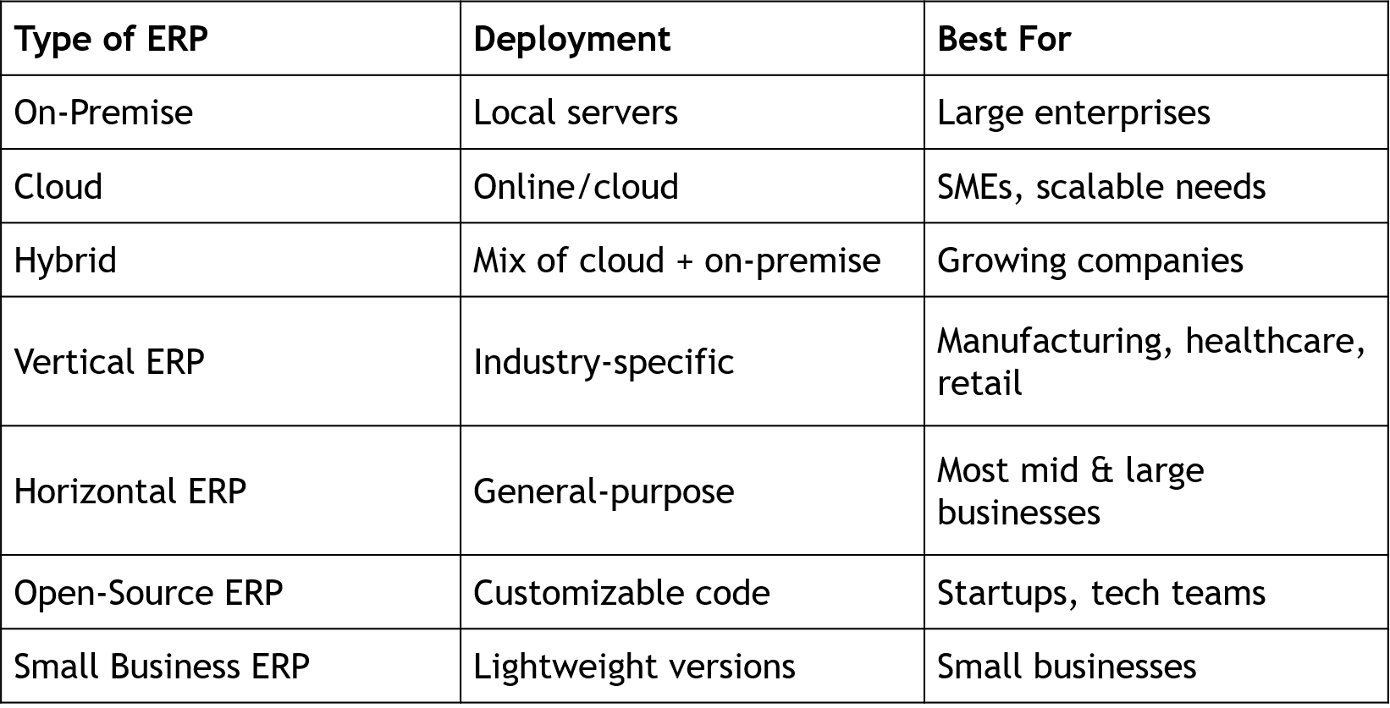

Benefits of ERP
- ERP systems provide many advantages by integrating different business functions into a single platform.
- Increased productivity and efficiency: Automating routine tasks reduces manual data entry and errors, speeding up operations.
- Cost savings: Streamlining processes, optimizing inventory, and improving supply chain management can lead to lower operational and inventory costs.
- Improved financial management: ERP systems simplify financial reporting, accelerate the financial close process, and provide accurate cash flow projections.
- Real-time data and analytics: A single source of truth provides real-time visibility into operational and financial performance, supporting faster and more informed decision-making.
- Better inventory management: Automation of inventory management reduces handling costs and helps optimize cash flow by ensuring sufficient stock levels.
- Enhanced collaboration: Centralizing data allows different departments to share information easily, improving teamwork and productivity.
- Improved customer service: Better access to customer information allows for quicker response times and more effective complaint resolution.
- Increased agility: Businesses can react more quickly to opportunities and market changes due to real-time data and more efficient operations.
- Scalability: ERP systems can grow with the business, allowing companies to add new functionalities as they expand without disrupting existing operations.
- Regulatory compliance: Automation of controls and the provision of audit trails help ensure businesses meet regulatory requirements.
- Enhanced data security: Role-based access controls and data encryption improve the protection of sensitive business information.
ERP vs CRM
